October 13, 2022

Monroe County Public Library, Meeting Room 2A & on Zoom, 3:30-4:30pm

Attendees:

In Person:

Zoom:

Facilitators:

Notes:

1. Welcome & Introductions
2. Agreements
   1. Respectful
   2. Ask with curiosity
3. Reviewing affinity diagram (control vs no control, knowledge vs no knowledge) from September meeting

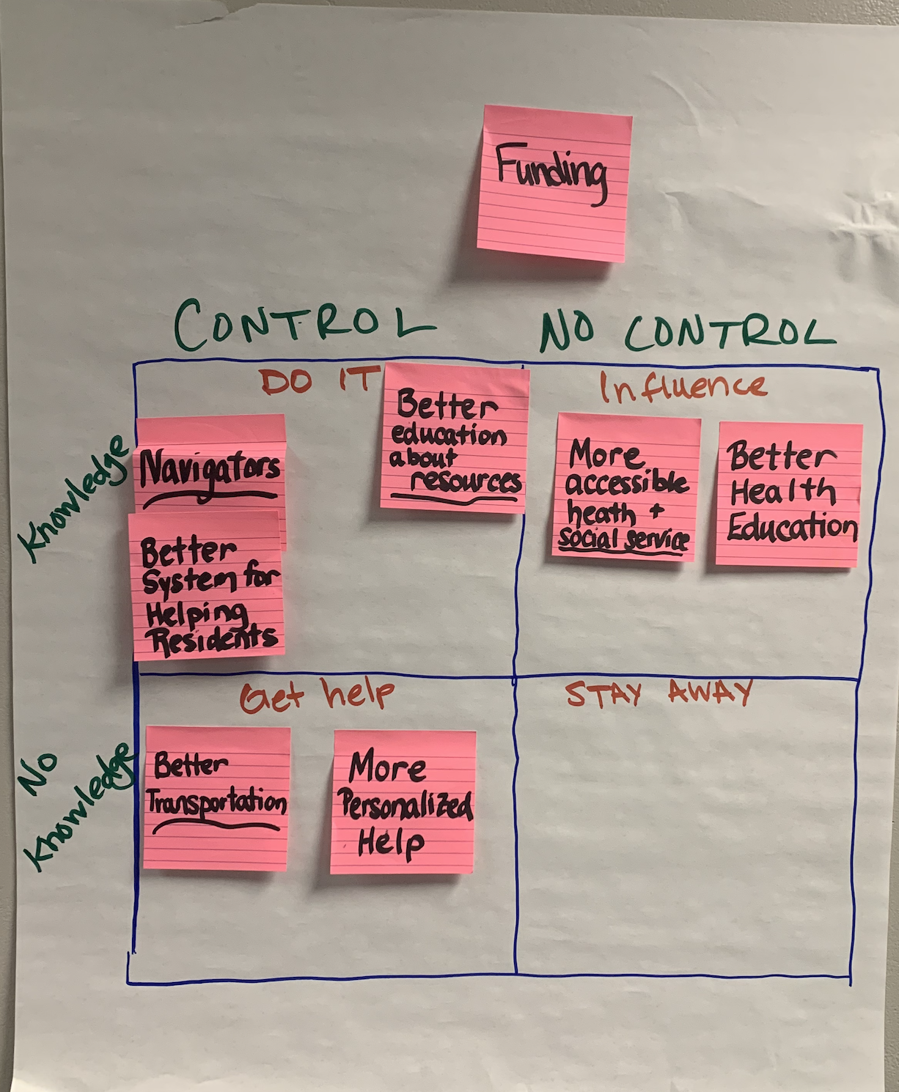

1. Identifying strategies for actionable items

[Link for live table](https://docs.google.com/document/d/1VPPse3Ch2UYDyqt7KKDVEPSjl8PD9w7anpXL8Zog3oM/edit?usp=sharing) : <https://docs.google.com/document/d/1VPPse3Ch2UYDyqt7KKDVEPSjl8PD9w7anpXL8Zog3oM/edit?usp=sharing>

| **Opportunity** | **Strategies** | **Who Can Help?**  Me / Who is Missing? | **Next Steps** |
| --- | --- | --- | --- |
| Funding | (control & knowledge - do it) |  |  |
| Navigators / Better System for Helping Residents | (control & knowledge - do it) |  |  |
| Better Education About Resources | (control & knowledge - do it) |  |  |
| More Accessible Health & Social Services | (knowledge & no control – influence) |  |  |
| Better Health Education | (knowledge & no control – influence) |  |  |
| Better Transportation | (control & no knowledge – get help) |  |  |
| More Personalized Help | (control & no knowledge – get help) |  |  |

1. Defining success of outcomes